These should be done before segregating the AP file.

Identifying Industry

Non Re & Non Rescheduled

- Insert New Column Named Industry After the Sec Description (Column AJ).
Illustration - Non Rescheduled and Non Restructured Loan File
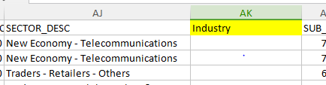

- Open the File Named Industry Mapping
- Using VLOOKUP Get the Industry By Mapping it to Sec Description

Illustration - Industry Mapping File table with Sec Description Mapped to Industry
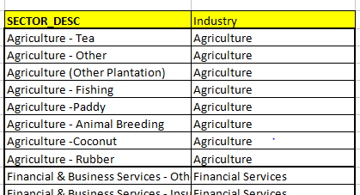

Illustration - Non Rescheduled and Non Restructured Loan File After doing VLOOKUP
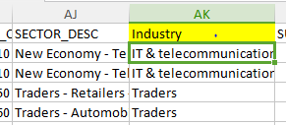

- Copy and paste the results as Values obtained from VLOOKUP.
- If the Sec description is #NA Update the Sec Description As “Others”.

Calculating Remaining Maturity

- When Converting Advance Portfolio File Column Q & R & AV (Expiry Date And ACCT_OPN and AS_ON_DATE) Should Be Converted As Dates Using Text to Column

- Inset New Column For YTM Next to EXPIRY DATE (Column “S” )

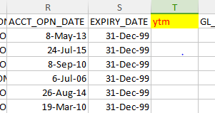

- Get the Value for YTM By Deducting EXPIRY DATE minus AS_ON_DATE Divided By 365
Using Below Excel Function (Screen Shot 2)

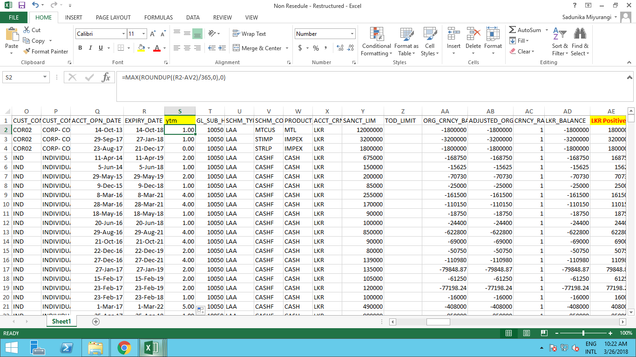

4. Do the paste Special for YTM Value.

Inserting Individual Impairment for Advance Portfolio

- Insert a New Column Next to Restructured Column Named ISL

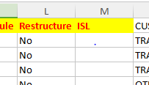

- Open the Individual Accounts File.
- Do A VLOOKUP to Get Result in the Column D from Individual Account File based on Account Number.

Illustration - Individual Impairment File (Column D text need to be obtained by VLOOKUP)
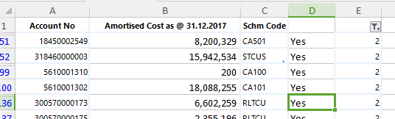

- Copy paste it As Values.
- Replace the #NA as “No” and keep All Other As “Yes”

Breaking up Security as Above below

- Inserting New Column Next to the Sanction Limit Called Limit LKR

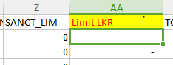
- Convert Sanction Limit to LKR (Column Z) By Multiply it by Currency Rate and get the results for Limit LKR Column.
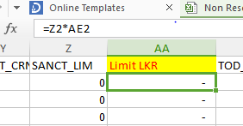

- Add two new Columns Next to Imm. Property(Column CW & CV)

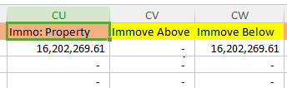

4. Name Two as Immove Above and Immove Below.
5. If Limit LKR >= 5mn take the Immov Property as Above or 0

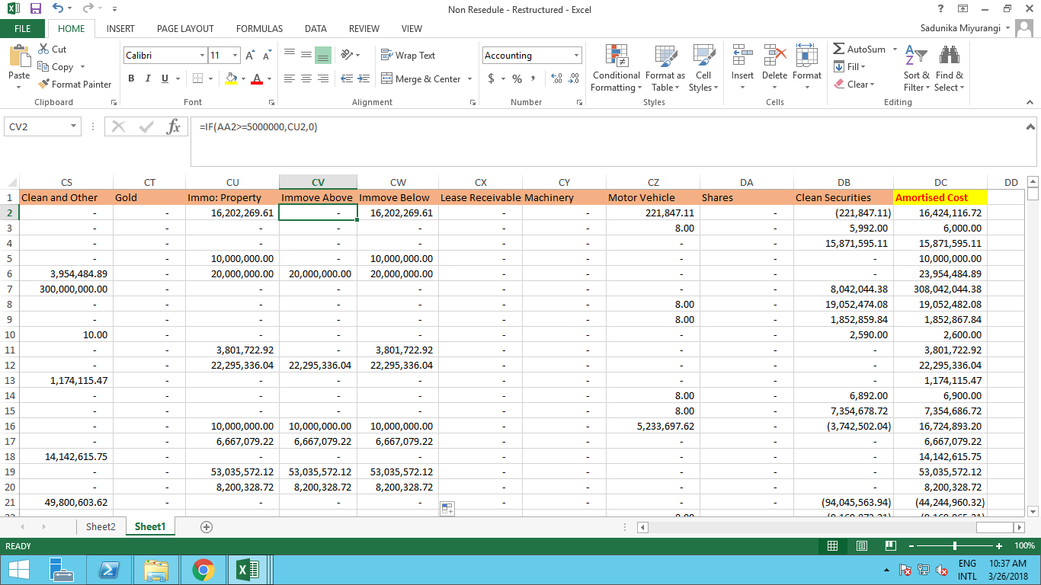

- If Limit LKR < 5mn take the Immov Property as Below or 0

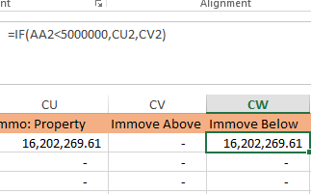

7. Paste Special both Columns Below And Above.

IMPAIRMENT COMPUTATION

- Create a Pivot Table As Below.

Illustration - Pivot Table Filters
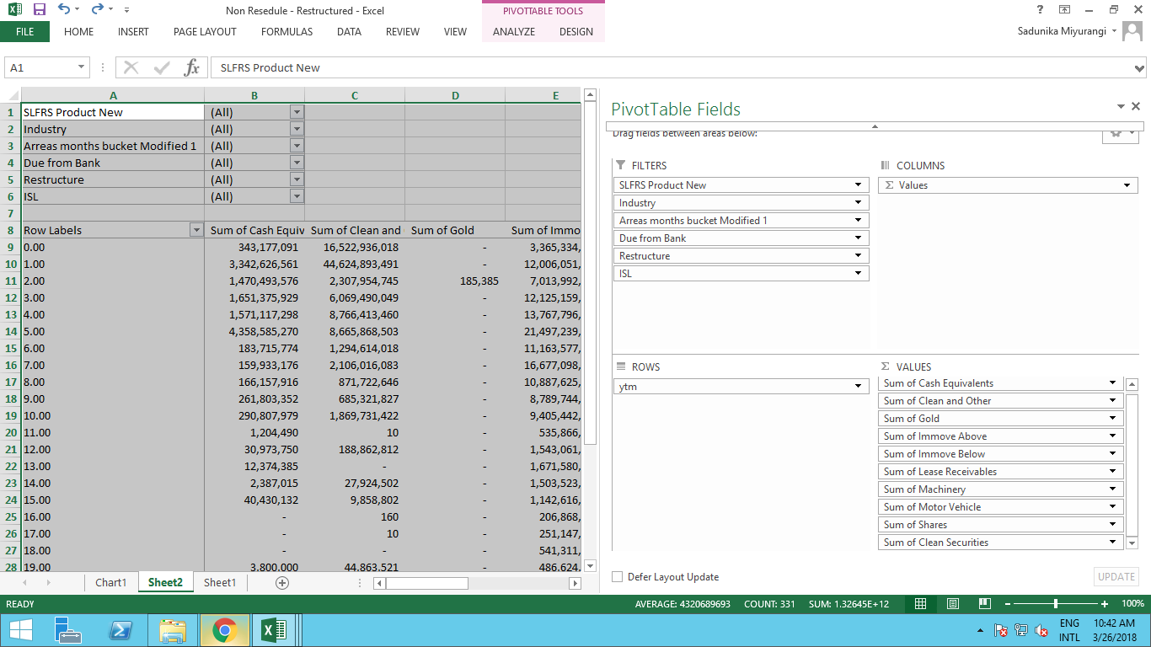

Illustration - Pivot table Fields

Update PD Rates Table

- Filter Pivot table by SLFRS product new - LTL & MTL(for Term Loans/Term Loans Specified As LTL & MTL)
- Filter the Relevant Industry
- Arrears Bucket for 0 days
- Due From Banks “NO”
- Filter ISL by “NO”

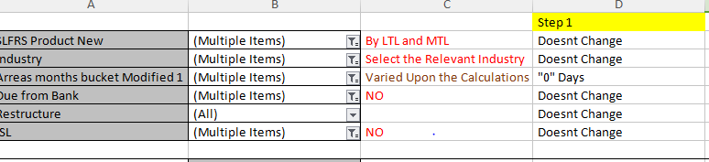

- Update the Security Wise totals for Computation Sheet in A Separate Workbook for Non Restructured and Non Rescheduled.
Illustration - Computation Sheet.
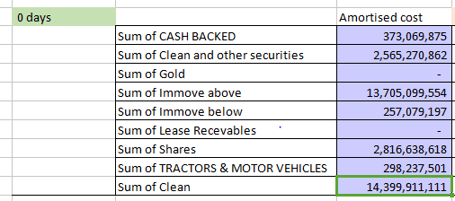

Illustration - Pivot table Data (Need to Replace the Totals for Each Relevant Security in the Computation Sheet)

Computation of PD for 0 Days and 0 30 Days

- Average tenor of the Product is given by the Customer.
- Average Int rate of the Product is given by the Customer.
- Using PMT Function Calculate the Monthly payment of a 1 rupee

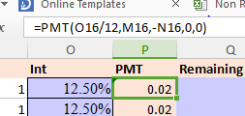

- Calculate the Outstanding Amount By Using PV function

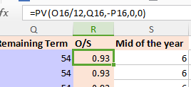

- Get the EAD value by Multiplying Security Wise Amortized cost by Outstanding Amount

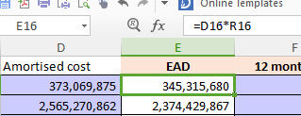

- Take the PD rates, Economic Factor rates (EFA), LGD rates, from relevant Tables, These Tables Need to be provided by Customer.

Calculation of Discount Factor using the Below Formula.

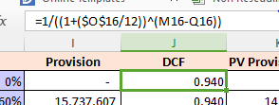

-Impairment Calculation for 0 days

Provision = EAD*PD (0 Days)*EFA*LGD

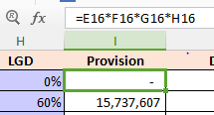

PV of Provision = EAD*PD (0 Days)*EFA*LGD*DCF

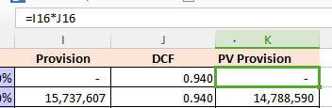

7. Filter the 0-30 Days Arrears Bucket

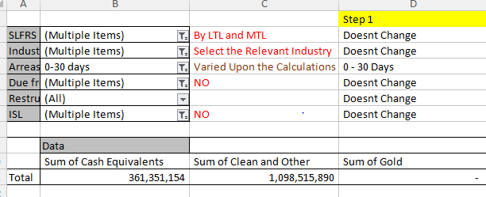

- Update the Relevant table in the Computation Sheet Based on the Pivot Table Results.

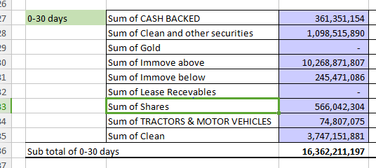

- Follow the Same Steps there After As Done in the 0 Days Computation

-Impairment Calculation for 0 - 30 days

Provision = EAD*PD (0-30 Days)*EFA*LGD

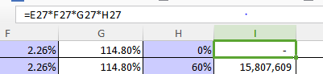

PV of Provision = EAD*PD (0 - 30 Days)*EFA*LGD*DCF

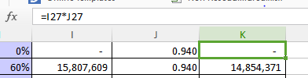

Impairment Calculation for 31-60 Days 61- 90 Days

- Filter the Arrears Bucket 31-60 days,
- Get the YTM As filter Criteria in the Pivot Table.
- Get the Filtered Values for YTM 0-1

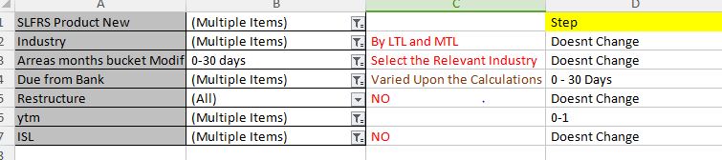

- Update the Computation Sheet for 31-60 and Default Point 1 table.

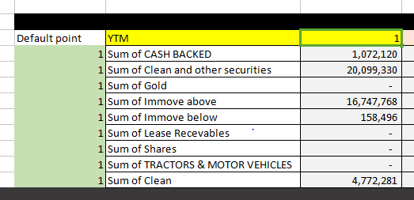

- Filter the Values Again By YTM Value 2

- Update the Default point 1 and 2 Tables By Using the Data in the Pivot Table

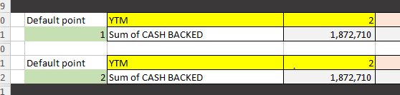

- Filter the Values Again By YTM 3

- Update the YTM 3 Tables by Using the Pivot Table data as above.

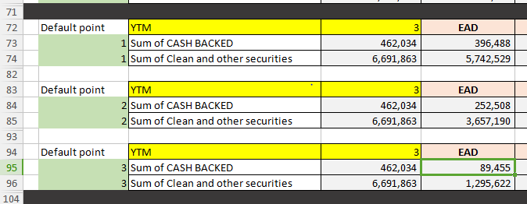

Note - Like Wise For Each YTM there will be equal Amount of Default Points (YTM =3 , Default Points 3) and Need to Calculate the PD Separately For Each Default Point there for the Number of Tables Required under Each YTM is Equals to the Value of YTM

Calculation

21. TERM of the Loan = YTM*12(No of Months per Year)
22. Interest Rate = Will Be Provided
23. Loan = Always Equals to 1

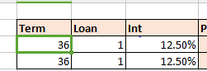

- Calculate the Payment Using PMT Formula As Below.

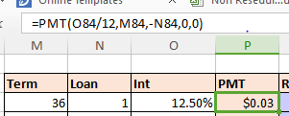

- Get the mid of the Year Value on the Assumption that Default Takes place on the mid of that Year.

=YTM (Default Point)*12-6

- Calculate the Remaining term by deducting Term from the mid of the Year Value.

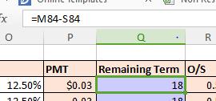

27. Calculate the Outstanding Amount Using PV Formula as Done Previously.

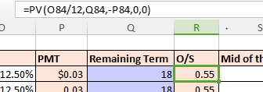

- Get the EAD for Each Default Points based on that Result.

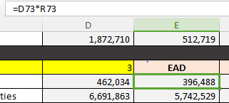

- Identifying PD for the Calculation
Note-PD Used to Calculate this Arrears Buckets is Incremental PD and that Will be Obtained by Getting 1st Default Point PD as 1 default Point and in the Second Default Point it Would Be PD of YTM 2nd Year - PD of YTM 1st Year Likewise for Each default Point Has to Decide the Incremental PD for Each Based on the Default Point Value.

Illustration-Two Year PD (PD of 31-60 bucket and YTM 1)

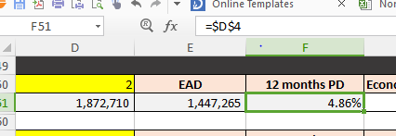

Illustration- PD Table
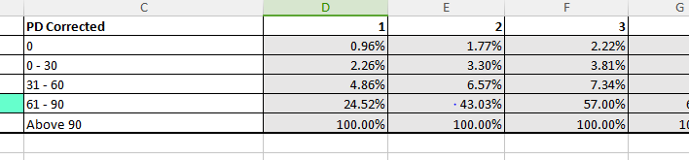

Illustration-Second Default Point PD (31-60 PD for YTM 2 - DP 1 PD)
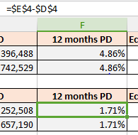

- Economic Factor and LGD will be provided by the Customer.

31. Filter the Pivot Table from 61-90 Days and Do the Same Steps Selected PD should be 61-90 days PD

Impairment Provision Calculation for 31-60 & 61-90 Days.

Provision n= EAD*PD (Relevant Arrears Days and PDn - PD (n-1))*EFA*LGD

PV of Provision n = EAD*PD (Relevant Arrears Days and PDn - PD (n-1))*EFA*LGD*DCF

.n=Default Point(YTM of PD)

Need to do Each activity Mentioned Above for All the Default Point Tables Under 31-60 & 61-90 Arrears Buckets.

Impairment Calculation for Above 90 days,

1. Filter the Values of the Pivot table for Arrears Buckets above 90 days
2. Get the total and Paste it to Computation Sheet
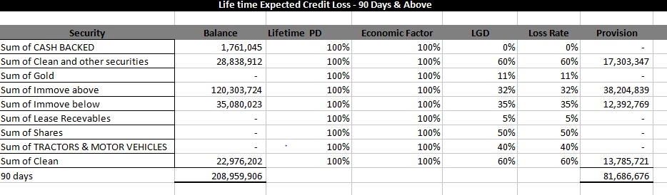

Impairment Calculation

EAD = Amortized Cost
PD=100%
EFA=100%
DCF=1

PV of Provision = EAD*PD*EFA*LGD*DCF

PV provision=EAD*LGD

Impairment Calculation Restructured
All other steps are same Except the Classification of Arrears Buckets
Classify 0 Days and 0-30 days and 31-60 All to be classified as 31-60 in generating the Pivot table. All Other Clarification Are Same

Impairment Calculation for Rescheduled
All other steps are same Except the Classification of Arrears Buckets
Classify 0 Days and 0-30 days and to be Classified as 31-60 in generating the Pivot table.31-60 61-90 and Above 90 All 3 are classified as Above 90.

-Impairment Calculation for 31-60 Days 61- 90 Days

Example YTM = 3

Default Point 1

Term Equals 12*3
Calculate the Payment using the PMT Function Explained above Step 16.
Calculate the Outstanding Balance Using PV Formula.
Identify 3 Default Points
Impairment Calculation for default point 1
Remaining term is 30 for Default point 1
Calculate the PV provision as below

PV of Provision = EAD*PD (31-60 Days and PD YTM = Default Point1)*EFA*LGD*DCF

Impairment Calculation for Default point 2

Remaining term is 18 for Default point 1
Calculate the PV provision as below

PV of Provision = EAD*PD (31-60 Days and PD YTM = Default Point2-DP1)*EFA*LGD*DCF

Same steps for 61-90 Days refer 61-90 Days PD

Impairment Calculation for Above 90 days,

Filter the Values of the Pivot table for Arrear Bucket above 90
And Get the total and Paste it to Computation Sheet
EAD = Amortized Cost
PV of Provision = EAD*PD100%*EFA1*LGD*DCF1

